Manatee County
Recovery Plan

State and Local Fiscal Recovery Funds
2025 Report

Manatee County
2025 Recovery Plan

Table of Contents

General Overview 2
Executive Summary 2
Uses of Funds 3
Promoting Equitable Outcomes 9
Community Engagement 10
Labor Practices 10
Use of Evidence 10
Performance Report 10

Project Inventory 24

GENERAL OVERVIEW
Executive Summary (An Evolutionary Process)
In March 2021, the American Rescue Plan Act of 2021 (ARP) established the Coronavirus State and Local Fiscal Recovery Funds (SLFRF) to provide state, local, and tribal governments with resources needed to respond to the pandemic and its negative economic effects to build a stronger, more equitable economy during the recovery. Manatee County was awarded and received $78.3 million in SLFRF funds with Treasury imposed deadlines to obligate all funds by December 31, 2024, and to fully expend those funds by December 31, 2026.
Beginning in April 2021, with initial assistance from Ernst & Young, Manatee County Government was able to quickly identify key components of the legislation and then provided guidance to the Board of County Commissioners (BOCC), internal departments and programs, and partner agencies, to access their extensive, existing community outreach avenues to develop an initial roadmap and implementation plan to respond to the physical and economic harm caused by COVID-19. BOCC work sessions and regular meetings further encouraged participation by the general public in person and via community access television to further refine the action plan. A prospective list of services, equipment and capital projects was established in January 2022 that would work toward building a strong and equitable recovery from the pandemic and economic downturn.
Manatee County demographics illustrate large aging, homeless and transient populations, resulting in a disproportional share of citizens that are most susceptible to COVID-19 and its harmful effects. In addition, because of exceptional year-round weather, the county population increases dramatically with seasonal residents and visitors during the winter months, stretching public health & safety, community, infrastructure, and other services to their capacity. The pandemic and its aftermath have further magnified the demand for those services.
Initially, the BOCC directed SLFRF funds towards mitigating and preventing the spread of COVID-19 and further emphasizing the health and safety of our citizens.
As of June 30, 2022, Manatee County had total expenditures of $12.8 million, with 98% of those dollars going towards prioritized public health & safety projects. Key outcome goals of those projects included the mitigation and prevention of positive COVID-19 cases in Manatee County by adding additional COVID testing, and vaccination facilities located in strategic areas across the county and the sanitization of public facilities and EMS medical equipment. Simultaneously, SLFRF funds were used to purchase ambulances and other EMS vehicles and approved for deploying advanced life support (ALS) and basic life support (BLS) personnel with the key outcome goal of reducing EMS response times to our citizens. In addition, the county established a public health data system to better identify and respond to emerging disease patterns, and finally, purchased new portable radios to increase communication quality with our Sheriff Deputies when responding to active 911 calls.
As the pandemic subsided, the BOCC and county administration refocused their attention from a COVID-19 emergent response to recovery projects. Increased population growth in the northern and eastern regions of the county necessitated increasing sewer capacity, building an EMS station, purchasing an additional ambulance, and improving the access road leading to that new EMS facility. In addition, various stormwater repair projects began, addressing localized flooding issues. And finally, in collaboration with the Florida Housing Coalition, studies to identify solutions for reducing homelessness were initiated.
As acknowledged in the American Rescue Plan Act of 2021, the pandemic had a significant negative impact on the health and welfare of American citizens, and to the economies of many communities across the United States. Consequently, the Department of Treasury provided a formula allowing each jurisdiction to calculate the amount of revenue loss due to the COVID-19 pandemic, and allowed state, local, and tribal governments to expand the use of SLFRF funds to include reimbursement for traditional government services. This expanded use of funds included projects which may have been restricted and/or excluded under the other sections of Treasury Guidance. The loss of revenue due to the COVID-19 pandemic in Manatee County was calculated to be $109.5 million dollars. However, the Guidance limits the calculation to be capped at the full SLFRF grant award, or $78.3 million.
In February 2023, the BOCC directed individual commissioners, county administration and county departments to reassess the remaining original, prospective projects with the following considerations: pandemic recurrence was no longer a factor, a review of revised Treasury Guidance, including a better understanding of Revenue Loss Provisions, and Treasury deadlines fast approaching. Consequently, on May 23, 2023, the BOCC reappropriated the remaining $52.6 million unobligated/unspent SLFRF funds to reimburse the payroll of the essential workers of Manatee County, a traditional government service.
As of June 30, 2023, Manatee County had obligations/expenditures of $16.2 million directed towards active and/or completed projects, with an additional $9.5 million appropriated to complete active projects. These projects represented $25.7 million or 32.8% of the total SLFRF grant with the remaining $52.6 million appropriated for essential payroll reimbursement.
Between July 1, 2023 - June 30, 2024, there were no new SLFRF projects established. However, following in the spirit of the American Rescue Plan Act, on August 3, 2023, the BOCC established a reserve from unrestricted funds, to provide generational impact projects that will continue the recovery of Manatee County beyond the deadlines established by the Treasury.
As of June 30, 2024, Manatee County had obligations/expenditures of $74.5 million or 95.1% of SLFRF funds towards active and/or completed projects. The remaining $3.8 million (4.9%) earmarked for one remaining project (Parrish Sanitary Sewer) currently in the pre-construction bidding process and the final administration cost of the SLFRF grant.
Accordingly, with essential worker payroll reimbursed and active projects moving to completion, as of June 30, 2025, $78.2 million or 99.8% of SLFRF funds were obligated or spent towards completed/active projects, with the remaining $147,656 (0.2%) earmarked for one remaining project (Parrish Sanitary Sewer) currently in construction process and the final administration costs of the SLFRF grant.
As noted in the opening paragraph, all SLFRF funds must be fully obligated by December 31, 2024, and fully spent by December 31, 2026. Accordingly, Manatee County has been monitoring and evaluating all projects for compliance with these critical deadlines since the inception of the grant.
Uses of Funds
With initial assistance from Ernst & Young and their Rapid Assessment Program, Manatee County Government was able to define an effective strategy to quickly identify key components of the legislation, facilitate discussions with departments, agencies, and programs to utilize their existing network of community outreach and to develop a prospective list of programs, services and capital projects that would build a strong and equitable recovery from the pandemic and economic downturn. The initial roadmap, implementation plan and initial project list was put in place in January 2022.
However, Manatee County’s use of SLFRF funds was and continues to be an evolutionary process from the inception of the American Rescue Plan Act in March of 2021 through the current reporting period. From actively combating an unknown, world-wide pandemic, to forming a recovery plan that emphasized social justice and climate change, to fully understanding all facets of the Treasury Guidance and its evolution to meet the needs of state, local and tribal governments, Manatee County has adapted its Recovery Plan and use of funds accordingly.
The initial strategy was designed to prioritize the immediate health and safety of the public and essential county employees, as we all faced COVID-19 and the aftermath of the pandemic. Use of funds included a rapid response for distributing personal protective equipment (PPE), identifying facilities and personnel for COVID-19 testing and vaccination sites, the sanitization of county facilities, ambulances, and emergency medical equipment. The pandemic also exposed weaknesses in the county’s ability to quickly respond to increased EMS and Sheriff Department 911 calls, and the inability to quickly identify trends in the spread infectious disease. Accordingly, additional use of funds was earmarked to include state-of-the-art Sheriff radios and communications equipment, a public health data scientist and system, a new EMS station in the fast-growing North River region of the county, and additional advanced life support and basic life support ambulances placed throughout the county. As of June 30, 2022, Manatee County had spent $12.8 million of SLFRF funds.
The next strategic use of SLFRF funds addressed community and infrastructure programs, services, and capital projects. The pandemic exacerbated the growing county homeless population and related necessary programs and services this disproportionally impacted group needs. The county initiated a study on homelessness with the Florida Housing Coalition and had initial discussions and site evaluations for the proposed veteran’s homeless shelter. In addition, investments in infrastructure such as providing free WIFI services in area parks was initiated and sewer and stormwater projects began with the objective of addressing technology, climate change and clean water initiatives. Overall, the recovery plan was working toward a healthier community and a strong, equitable economic recovery.
As of June 30, 2023, Manatee County had obligations / expenditures of $16.2 million towards active and / or completed projects, with an additional $9.5 million designated to complete those currently underway. These projects represented $25.7 million or 32.8% of the total SLFRF grant.
However, simultaneously with the Recovery Plan Year End of June 30, 2023, the county reassessed the initial, prospective projects list, currently active projects, and projects to be started at a later date. That reassessment, under the auspices of a more in-depth knowledge of existing and newly released Treasury Guidance, and fast approaching Treasury deadlines provided county administration with a revised, final strategic use of SLFRF funds.
On May 23, 2023, the BOCC reappropriated the remaining $52.6 million unobligated /unspent SLFRF funds to reimburse the payroll of the essential workers of Manatee County, a traditional government service. Accordingly, prospective projects not started, projects no longer meeting BOCC expectations or those that could not meet Treasury deadlines were removed from further consideration. A revised project list was established as of 6/30/2023 and reported accordingly.
Between July 1, 2023 - June 30, 2024, no projects were added, and six projects were moved to completed status. In addition, remaining projects were again reassessed against criteria stated above with two projects removed and SLFRF funds reallocated to reconcile final project costs for both active and completed projects.
As of June 30, 2024, Manatee County had obligations/expenditures of $74.5 million or 95.1% of SLFRF funds towards active and/or completed projects. The remaining $3.8 million (4.9%) earmarked for one remaining project (Parrish Sanitary Sewer) currently in the pre-construction bidding process and the final administration cost of the SLFRF grant.
As of June 30, 2025, $78.2 million or 99.8% of SLFRF funds are obligated or spent towards completed / projects in process, with the remaining $147,656 (0.2%) appropriated for the one remaining project (Parrish Sanitary Sewer) currently in construction process and the final administration costs of the SLFRF grant.
The following SLFRF Project Status Reports represent Recovery Plan Years 2022, 2023, 2024 and 2025 respectively:

Promoting Equitable Outcomes
Manatee County Government has consistently identified neighborhoods, communities and populations that are historically underserved or marginalized through its extensive outreach programs within County Government and with partners, service providers and stakeholders in the community. The Community and Veterans Services Department (CVS), Neighborhood Connections Division for example, identifies, connects, collaborates, provides resources and works closely with neighborhoods to navigate through potential barriers to equitable outcomes of available programs and services.
In addition, through their monthly electronic magazine, “Neighborhood Connections”, the Division provides information on community activities/events and reaches over 100,000 individuals. They collaborate with other departments in encouraging citizens to participate in government decision-making through in-person community meetings, informational sessions, and online surveys.
Finally, CPD Maps (able to identify Low Income Areas by map), Qualified Census Tracts Data, Qualified Census Tract Map and HUD AFFH Mapping tool (R/ECAP) are used and readily available to CVS and all Manatee County departments and agencies in the continual effort to address the needs of the most vulnerable members of our community:
- https://egis.hud.gov/cpdmaps/
- https://www.huduser.gov/portal/datasets/qct.html
- https://www.huduser.gov/portal/sadda/sadda_qct.html
- https://egis.hud.gov/affht/
Further, the Manatee County Department of Public Safety, Division of Emergency Management, worked with other County Departments to locate COVID-19 testing and vaccination sites in or near communities most harshly impacted by the pandemic. Earlier in the pandemic, the Florida Division of Emergency Management (FDEM) and Federal Emergency Management Agency (FEMA) Region 4 identified site placement data throughout the state using social vulnerability assessment tools and indices (EG the Social Vulnerability Index or SVI, which provides a rating down to the census tract level). That insight from FDEM leadership assisted greatly in our understanding of how socioeconomic factors were linked to infections and helped determine testing and vaccine site placement and promoting equitable outcomes.
Because of Manatee County’s continual equity effort, as projects were identified as enumerated uses of SLFRF funding, equitable outcomes were strongly considered. SLFRF projects selected as of June 30, 2023, included COVID-19 testing and vaccination sites as identified above, infrastructure projects, including free WIFI, and our collaborative effort with the Suncoast Partnership to End Homelessness and the Florida Housing Coalition commissioning a study to better address housing and the expanding needs of the homeless population in the county. Data to document this humanitarian crisis is available at the following website:
- https://www.suncoastpartnership.org/point-in-time

Community Engagement
With initial assistance from Ernst & Young and their Rapid Assessment Program, Manatee County Government was able to define an effective strategy to quickly engage community organizations, partners, providers, and members. Through discussions with elected officials and county department, agency, and program personnel, it was requested that they utilize their existing extensive community outreach network to openly solicit ideas and receive feedback to develop a prospective list of programs, services and capital projects that address the County’s strategic plan to combat the harmful effects of COVID-19 and its negative impact on the community and to promote an equitable economic recovery. Please see Equitable Outcomes above. In addition, the American Rescue Plan Broadband Summit at the University of South Florida included Manatee County Government departments, agencies and program personnel, Ernst & Young consulting and community partners including the Manatee Community Foundation, Economic Development Council, Chamber of Commerce and other providers and stakeholders to discuss projects that would benefit the community.
The prospective list of projects was brought to the BOCC for assessment and approval through both work sessions and commission meetings open to the public. All BOCC work sessions and meetings require time for both written and oral public commentary for meeting attendees in person and over Manatee Government Access Television. Meeting agendas and minutes are part of the public record and available via the County website.
The following is a list of partnering community organizations that reach all demographics in the county, including the most underserved and traditionally marginalized populations:
https://www.mymanatee.org/departments/neighborhood_services/agency_funding_requirements/grants___special_projects
Other outreach and community engagement activities are also outlined in other sections of this Summary Report.
Labor Practices
The BOCC has allocated SLFRF funding to address the extensive homeless population in Manatee County, sewer expansion, stormwater projects and other capital projects. However, as of June 30, 2024, there are no active infrastructure or capital projects that require labor standards, project labor agreements, community benefit agreements, prevailing wage requirements or local hiring. Because of the revenue loss calculation prescribed by the US Department of Treasury, infrastructure and capital projects reported by Manatee County qualify under expense category 6.1 and are not subject to the Labor Standard requirements.
Use of Evidence
As of June 30, 2024, Manatee County has not used SLFRF funds to implement programs and services that utilize evidence-based interventions to evaluate outcomes.
Performance Report
Manatee County has incorporated performance management metrics into each project funded through SLFRF funds and each user group or department uses key performance indicators to evaluate the outcome or effectiveness of the use of SLFRF funds. Because various projects seek the same or very similar outcome goals, the same performance indicators and reporting metric are used in the evaluation process for those projects.
COVID-19 impacted so many lives in the community and like other areas of the country, the health of our citizens was at risk as the pandemic spread from neighborhood to neighborhood. The pandemic also exposed areas of concern in the areas of public health and safety as our essential county workforce was subject to the same illness in addition to the outcomes of mitigation and prevention measures. Quarantining, social distancing and disinfection procedures further reduced the ability to perform essential functions in a timely manner. As stated earlier in this report, because Manatee County prioritized the health and safety of its citizens first, initial spending of SLFRF funds and related performance reporting is directed to health and safety performance metrics.
Performance management evaluation at the highest levels includes reducing response times for EMS calls, providing vaccinations to the general public, reducing positive COVID-19 cases among county employees, and reducing or eliminating numerous communication issues with the Sheriff Department emergency response equipment. Additional performance metrics include percentage of completion for infrastructure projects and the installation and integration of additional public health & safety equipment / system and finally, completion of studies commissioned to evaluate homelessness.
Projects using the same indicators will be grouped accordingly below. However, in the Project Inventory Section, each project identifies its performance management metric separately.

Performance Reporting for Completed or Active Projects

Performance Metric: EMS Response Times

Project: 1.14 – 33122 Project Name: 1.14-January-March 2022 (ALS AMB Cancel)
Project: 1.14 – 63022 Project Name: 1.14 -April-June 2022 (Two EMS SUV)
Project: 6.1-01012023ALS Project Name: 6.1-Jan2023ALS (ALS Staffing)
Project: 1.14-7312022BLS Project Name: 1.14-July2022BLS (BLS Ambulances)
Project: 6.1-04012023BLSS Project Name: 6.1-Apr23BLSS (BLS Staffing)
Project: 1.14-7312022MW Project Name: 1.14-July2022MW (Moccasin Wallow AMB)

Output Measure: The output measure was placing additional ALS/BLS/SUV equipment in service and / or hiring full-time Advanced Life Support and Basic Life Support EMS staff to respond to increased 911 calls.

Reporting Metric: EMS Average Response Times.

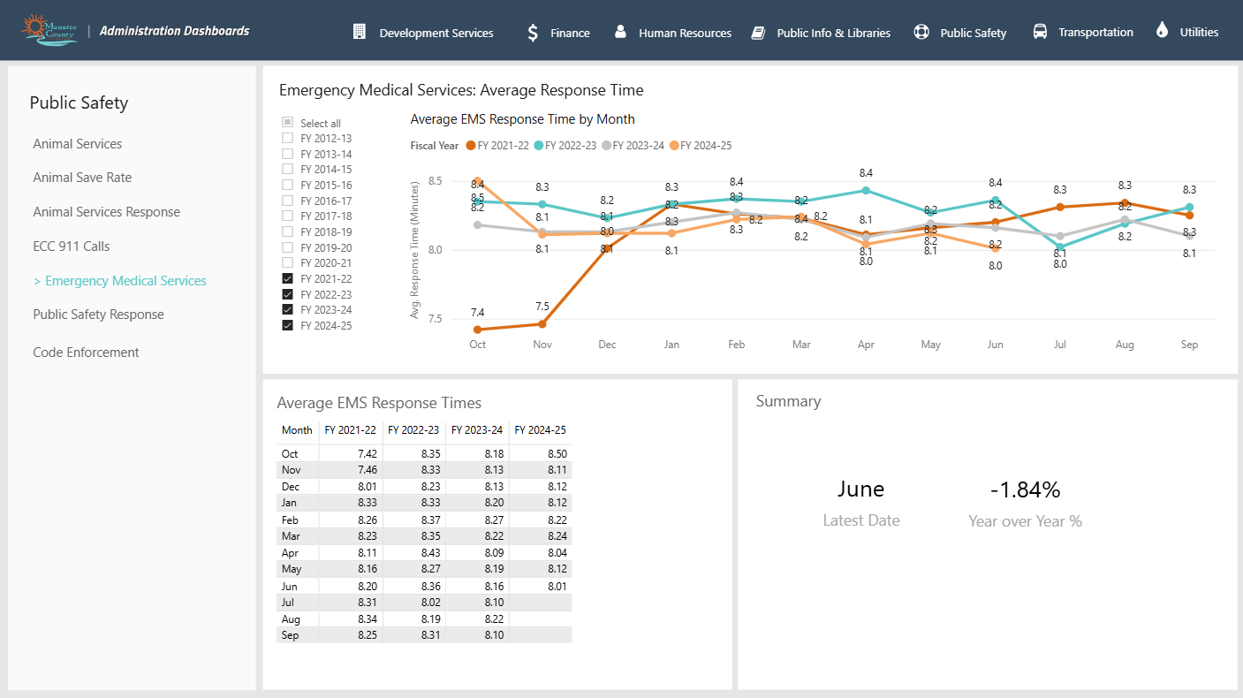

Performance Metric: COVID-19 Vaccinations

Project: 1.1 – 1231 Project Name: 1.1 - March-December (Vaccination Site Support)
Project: 1.8 – 1231 Project Name: 1.8 - March-December (Vaccination Site Support & Command Center Equipment

Output Measure: The output measure is establishing, staffing, maintaining and administration of two temporary vaccination sites.

Reporting Metric: Vaccinations administered while project was active. (Please see chart below):
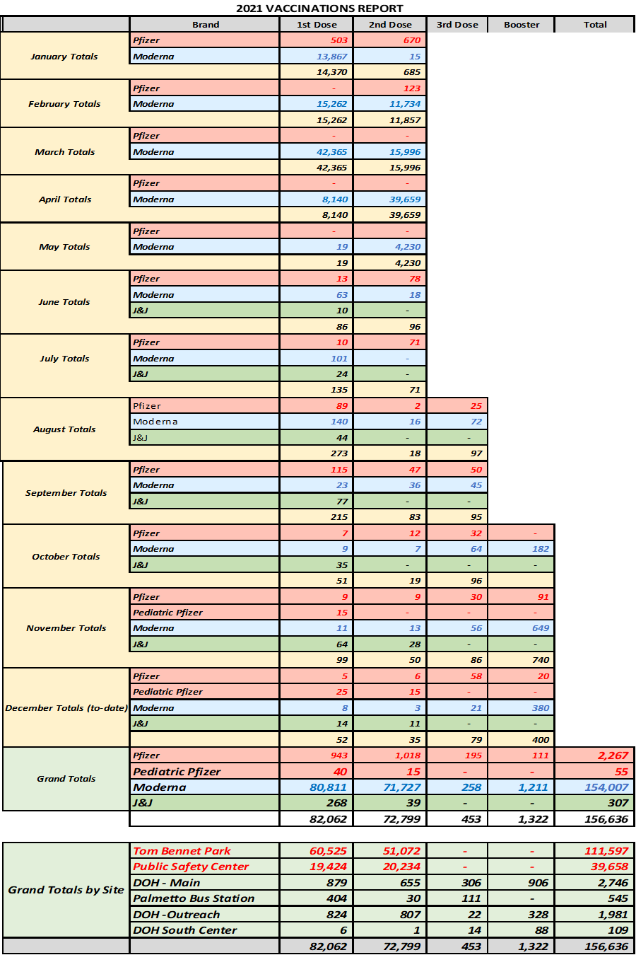

Performance Metric: COVID-19 Reporting
Project:1.12-1231 Project Name: 1.12-March-December (Sanitization County Buildings)
Project: 1.5-1231 Project Name: 1.5-March-December (PPE)
Project: 1.2-1231 Project Name: 1.2-March-December (Medical Office COVID testing)
Project: 1.2- DOH Project Name: 1.2-DOH (DOH COVID Testing)

Output Measure: The output measure was purchasing needed supplies and performing the sanitization work of county buildings (project one); purchasing PPE supplies (project two); COVID-19 tests administered - DOH: 9,501 and Medical Office - 40 tests administered (projects three and four)
Reporting Metric: Weekly positive COVID test results among all County employees at the summary and department levels. Summary data is provided here since inception (3/15/2021). Only one weekly department level report is provided in this report due to the volume of information. However, all weekly detail reports are available as needed.
Please note that due to the evolution of the COVID-19 pandemic County Administration suspended reporting COVID-19 cases as of January 22, 2023.
June 30, 2022- Summary Level Reporting Data (March 15, 2021 – July 3, 2022):

Week of 06/26/2022 Department Level Reporting (More Detail)
June 30, 2023- Summary Level Reporting Data (July 10, 2022 – Jan 22, 2023):
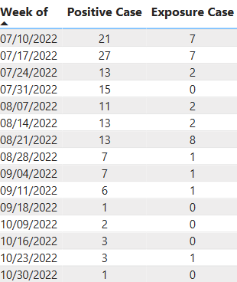
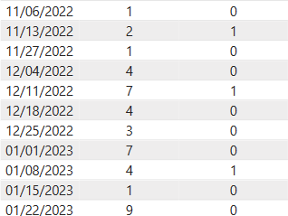

Week of 01/22/2023 (More Detail)
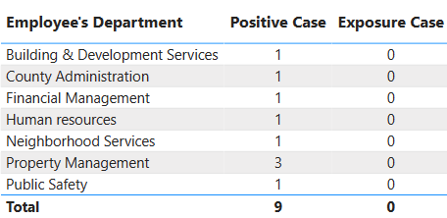

Performance Metric: Radio Call/Communication Errors
Project: 1.7-63022 Project Name: 1.7-April-June 2022 (Sheriff Dept Radios)

Output Measure: The output measure was completing the rollout by placing 1027 portable (personal) radios and related equipment in service with Sheriff Deputies.

Reporting Metric: Increased functionality of portable radios including GPS mapping / signaling functions and mutual aid response (out of area coverage); and monthly communication error rates for high call failure rates, loss of signal / reception with a Motorola based zone controller rollover, low receive audio and inconsistent large-scale building coverage. For the initial reporting period March 2022 – June 2022, the metrics were as follows:
- 964 Portables (100%) GPS Mapping
- 964 Portables (100%) mutual aid response (out of area coverage)
- 652,885 (push to talk) communications; 15 communication errors.
- 89 School Buildings tested, 8 call failures.

For July 2022 – June 2023, the metrics were as follows:
- 1027 Portables (100%) GPS Mapping
- 1027 Portables (100%) mutual aid response (out of area coverage)
- 1,233,272 PTT (push to talk) communications; 15 communication errors.
- 90 School Buildings tested, 0 call failures.

For July 2023 – June 2024, the metrics were as follows:
- 1027 Portables (100%) GPS Mapping
- 1027 Portables (100%) mutual aid response (out of area coverage)
- 1,287,535 PTT (push to talk) communications; 4 communication errors.
- 90 School Buildings tested, 0 call failures.

Performance Metric: Reporting of Public Health on County Dashboard
Project: 6.1-10012022PHDS Project Name: 6.1-Oct2022PHDS(Public Health Data Sys)
Output Measure: The output measure is collecting public health & safety related data (i.e. disease complications and mortality, mitigating or aggravating behaviors, or co-morbid conditions and leading risk factors, etc.), compiling surveillance tools by the Health Data Scientist and EMS Data Analyst, monitoring the results of that data, and sharing timely reports and reliable information to help enhance recommendations and local decision making.

Reporting Metric: Numerous ongoing and ad hoc data collection, interpretation, and reporting projects by the Public Health Data System (PHDS). Initial implementation is 60% complete as of June 30, 2023, with the Health Data Scientist and EMS Data Analyst onboarded and actively collecting data and mapping processes. Project is 100% implemented as June 30, 2025, and includes extensive dashboard reporting. Dashboard descriptions and example of selected screens are as follows. Full dashboard reports will be provided upon request.

Rainbow Health Dashboard
A data collection platform was designed to enable custom data storage for each community health program. A data pathway was established and connected to the primary data source, RainbowHealth. Relationships and models were developed between the data tables to ensure comprehensive data integration. Various visualizations, including Cards, Bar Charts, Stacked Bar Charts, Tables, Line Charts, Histograms, and Pie Charts, were created to display key metrics such as total referrals, accepted referrals, referrals by source, monthly distribution, and demographic data for various programs. Slicers for calendar year and providers were incorporated to facilitate data ﬁltering. The report was formatted to align with the Manatee County branding design and logo for marketing cohesion. Frequency protocols for scheduled data refreshes were established to ensure regular updates, and VPN installation was completed on multiple administrative devices to enable live reporting access.

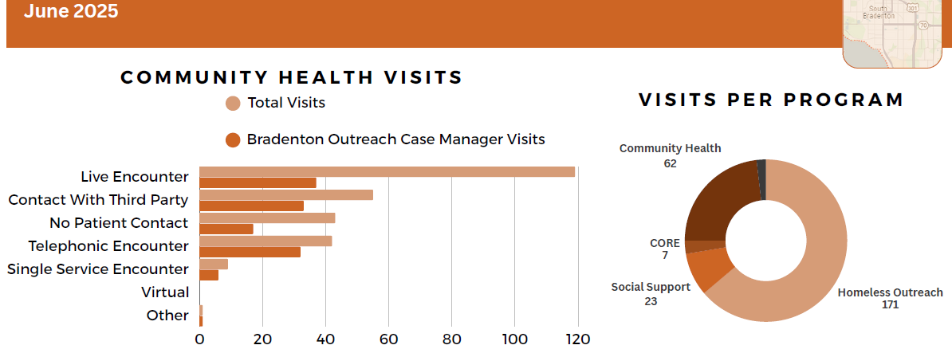

Internal Opioid Dashboard
To create the Internal Opioid Power BI report, data from various sources, including opioid emergency transport data, open data sources, and government data sources, was collected, extracted, and imported into Power BI Desktop. The data was then cleaned and transformed to ensure accuracy and consistency. Relationships between data tables were developed as needed, and the report layout was designed using appropriate visualizations such as bar charts, line charts, and maps to eﬀectively represent the data. These visualizations were conﬁgured with relevant ﬁelds and ﬁlters, and interactivity features such as slicers and drill-throughs were added to enhance user experience. The Manatee County branding design and logo were applied and formatted to the report for marketing cohesion. Additionally, frequency protocols were established for scheduled data updates.
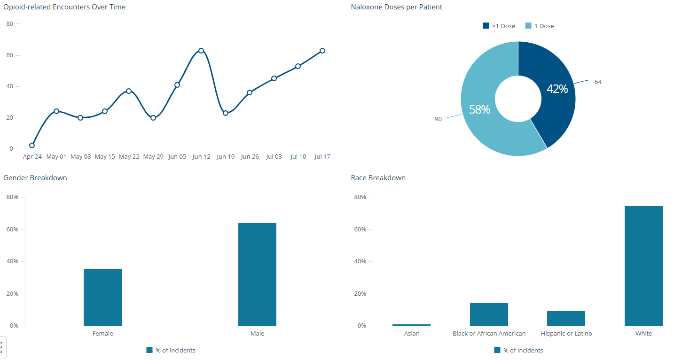

EMS Data Dashboard
The dashboard derives its data from the Manatee County 911 CAD system via integration with Microsoft Power BI, ensuring daily updates. It provides comprehensive insights intended for public interpretation, encompassing data spanning up to three calendar years, including the current year. Key metrics featured include incident counts, transport statistics, transport percentage, and call volumes categorized by year, month, day, and hour.
Additionally, the EMS Data Dashboard includes detailed zip code analyses, highlighting average response times, average transport durations, and critical metrics such as the ninety percent response time and ninety percent response high acuity time. Visual representations within the dashboard encompass graphs illustrating incident types, event distribution over hours, and acuity levels. Furthermore, the dashboard incorporates two distinct maps: a heat map and a shape map, depicting event distributions across Manatee County.

This structured approach ensures that stakeholders and the public can eﬃciently access and interpret essential emergency services data for informed decision-making and resource allocation purposes.
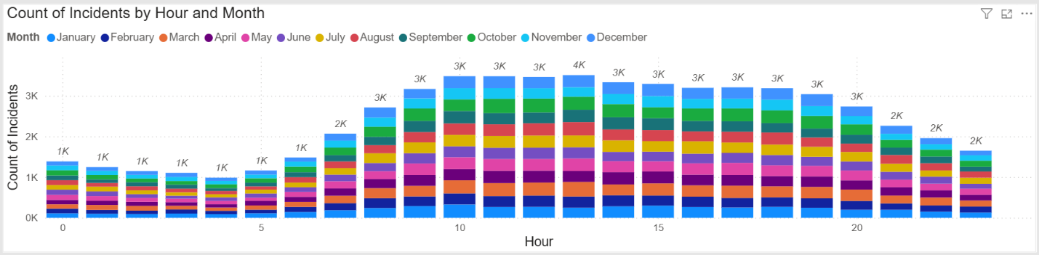

Alpha Unit Dashboard
The dashboard draws its data from the ESO software utilized universally by our ﬁeld staﬀ, ensuring daily updates. It serves as a critical tool for EMS administrators, providing profound insights into the operational performance of Alpha (ALS) ambulances in the ﬁeld. Key metrics prominently featured include average chute time and its associated percentage, indicating units enroute within the critical ﬁrst minute. Additionally, it tracks the count of patients treated within and outside chute time standards per unit, patient disposition outcomes per unit, Alpha Unit destinations, transport percentages per unit, call volume analysis, and EMD complaints per unit.

Graphical representations within the dashboard span various dimensions such as unit-speciﬁc metrics, hospital- speciﬁc data, unit call volume trends by hour, disposition percentages, and EMD compliance rates. This structured approach facilitates a comprehensive top-down assessment of how our Alpha units align with the stringent standards of Manatee County EMS, supporting informed decision-making and continuous improvement initiatives.

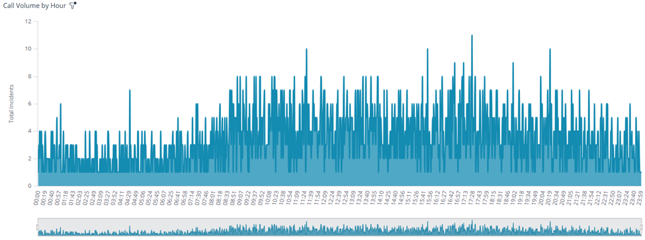
Performance Metric: Evaluating Completed Study from FHC
Project: 6.1-7312022FHC Project Name: 6.1-July2022FHC (Study on Homelessness)
Output Measure: The output measure is the completed study from the Florida Housing Coalition.
Reporting Metric: Evaluating the results of the Florida Housing Coalition study to better understand and utilize resources available to the homeless population of Manatee County. Project is at 100% completion as of June 30, 2024. The study is titled, “Manatee County’s Roadmap to Address Homelessness.” And is 50 pages long. The title page, table of contents and executive summary are included in this recovery report. The full report is available upon request.
Reporting as of June 30, 2024, is as follows:
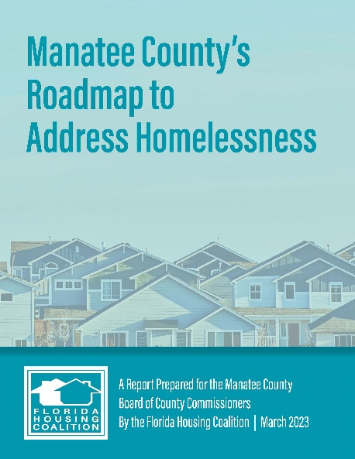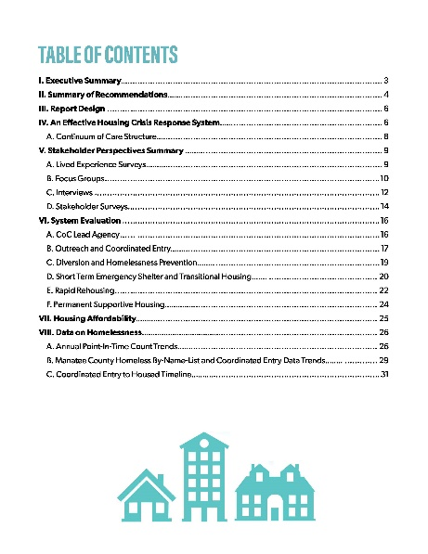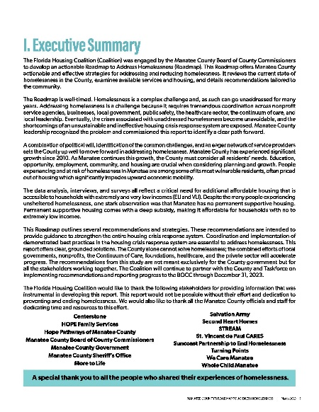

Performance Metric: Percentage of Completion-Construction
Project: 6.1-10012022MW Project Name: 6.1-Oct2022MW (Moccasin Wallow EMS #22)
Output Measure: The output measure is completion of the MW Station #22.

Reporting Metric: Percentage of completion of the building project. Percentage of Completion:>1%. CMAR / GMP (Purchase Order) placed. Groundbreaking 6/4/2024.

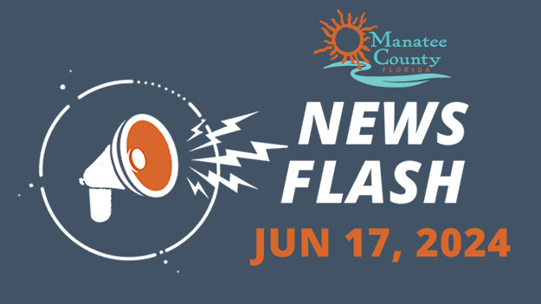
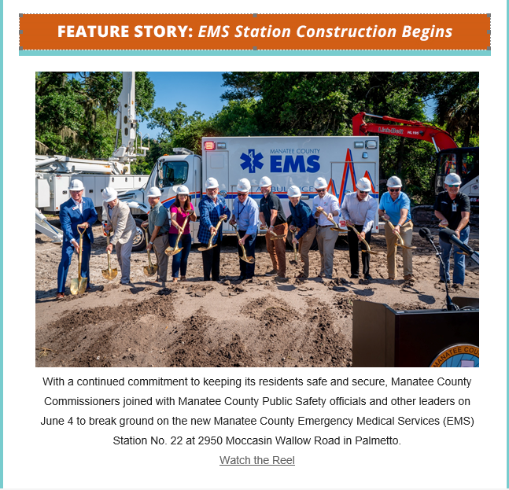

Performance Metric: Percentage of Completion-Construction
Project: 6.1-01012023PSWR Project Name: 6.1-JAN2023PSWR (PARRISH SEWER)
Output Measure: The output measure is completion of the sewer project.

Reporting Metric: Percentage of completion of the sewer project. Percentage of Completion: <10%. Design complete. CMAR/GMP selection in process. Construction not begun at 6/30/2024.

Performance Metric: Percentage of Completion-Repair
Project: 6.1-01012023SW9TH Project Name: 6.1-JAN2023SW9TH (SW 9TH ST)
Output Measure: The output measure is completion of the stormwater repair project.

Reporting Metric: Percentage of completion of the stormwater repair project. Percentage of Completion: 100%.

Performance Metric: Percentage of Completion-Repair
Project: 6.1-10012022SW4TH Project Name: 6.1-OCT2022SW4TH (4TH AVE)
Output Measure: The output measure is completion of the stormwater repair project.

Reporting Metric: Percentage of completion of the stormwater repair project. Percentage of Completion: 100%.

Performance Metric: Percentage of Completion-Repair
Project: 6.1-10012022SW55TH Project Name: 6.1-OCT2022SW55TH (55TH AVE)
Output Measure: The output measure is completion of the stormwater repair project.

Reporting Metric: Percentage of completion of the stormwater repair project. Percentage of Completion: 100%.

Performance Metric: Percentage of Completion-Payroll Reimbursement
Project: 6.1-09302023PR Project Name: 6.1-SEPT2023PR (PR REIMBURSEMENT)
Output Measure: The output measure is reimbursement of government services payroll.

Reporting Metric: Percentage of completion of the reimbursement. Percentage of Completion: 100%.

Performance Metric: Percentage of Completion-Construction
Project: 6.1-10012022MWRD Project Name: 6.1-Oct2022MWRD (Moccasin Wallow Rd)
Output Measure: The output measure is completion of the access road to MW Station.

Reporting Metric: Percentage of completion of the road project. Percentage of Completion: 100%.

Performance Metric: EMS Response Times

Project: 1.14-7312022MW Project Name: 1.14-July2022MW (Moccasin Wallow AMB)
Output Measure: The output measure is placing the Moccasin Wallow Ambulance in service.

Reporting Metric: Once Ambulance is placed in service: EMS response times. Percentage of Completion: 100%.

Performance Metric: Payroll Reimbursement
Project: 6.1-09302023PR Project Name: 6.1-SEPT2023PR
Output Measure: The output measure is reimbursement of payroll through the use of revenue loss.

Reporting Metric: Percentage of completion of the reimbursement. Percentage of Completion: 100%.
Performance Metric: Payroll Reimbursement
Project: 6.1-07012024PR Project Name: 6.1-JULY2024PR
Output Measure: The output measure is reimbursement of payroll through the use of revenue loss.

Reporting Metric: Percentage of completion of the reimbursement. Percentage of Completion: 100%.
Performance Metric: Payroll Reimbursement
Project: 6.1-10012024PR Project Name: 6.1-OCT2024PR
Output Measure: The output measure is reimbursement of payroll through the use of revenue loss.

Reporting Metric: Percentage of completion of the reimbursement. Percentage of Completion: 100%.

Performance Metric: Percentage of Completion-Installation & Integration
Project: 6.1-7312022REM Project Name: 6.1-July2022REM
Output Measure: The output measure is receipt and integration of the portable remote Public Safety Answering Point (PSAP) system with the VESTA 911 operations.

Reporting Metric: Percentage of completion of the purchase and integration. Percentage of Completion: 0%. Purchase Order Cancelled. Project Cancelled. Equipment not received at 6/30/2024.

Project Inventory of All Projects

Public Health & Safety

Project: 1.14 – 33122 (Cancelled) Project Name: 1.14 - January - March 2022 (ALS AMB)
Funding amount: $0
Project Expenditure Category: Cancelled and removed from SLFRF

Project Overview
This project was cancelled and removed from the SLFRF Project & Expenditure Report. This was for the purchase of 2 ALS ambulances specifically outfitted with additional equipment for treating COVID patients.

Project: 1.14 – 63022 Project Name: 1.14 -April-June 2022 (Two EMS SUV)
Funding amount: $82,874 PO Amt: $0 Exp Amt: $82,874
Project Expenditure Category: 1.14-Other Public Health Services

Project Overview
Purchase of two EMS SUV vehicles equipped with emergency lighting, auxiliary power and other safety and medical equipment; for rapid response of additional EMS personnel and transportation of supplies as COVID-19 call volume increased the demand for emergency medical services.

The two EMS SUV were delivered in April 2022 and put in service immediately. The timeline is the useful life of the vehicle. Output is placing the equipment in service. The intended outcome is believed to be with more ambulances and rapid response EMS vehicles available for public health and safety, response times to EMS calls should decrease.

Use of Evidence

The goal of this project is to increase public health and safety by reducing ambulance response times. This project does not use evidence-based interventions, accordingly, $0 are allocated for this purpose.

Performance Report

Key performance indicators are the ambulance response times to 911 calls. EMS responds to all calls on a first-come, first-serve basis. Calls are not identified by race, gender, income, or other measures. The outcome goal is reduced response times.
Project: 6.1-01012023ALS Project Name: 6.1-Jan2023ALS (ALS Staffing)
Funding amount: $2,088,405 PO Amt: $0 Exp Amt: $2,088,405
Project Expenditure Category: 6.1 – Government Services

Project Overview
In an effort to assist with increased ambulance utilization, limited supervisory oversight and to combat workplace fatigue, up to 28-FTE will be added to improve Advanced Lifesaving Support EMS systems capacity. Human Resources began hiring additional FTE EMS staff 1st QTR 2023.
Use of Evidence

The goal of this project is to increase public health and safety by reducing ambulance response times. This project does not use evidence-based interventions, accordingly, $0 are allocated for this purpose.

Performance Report

Key performance indicators are ambulance response times to 911 calls. EMS responds to all calls on a first-come, first-serve basis. Calls are not identified by race, gender, income, or other measures. The outcome goal is the reduction of response times. However, with the purchase and utilization of Basic Life Support ambulances EMS calls will be triaged to allocate resources between ALS and BLS 911 calls.

Project: 1.14-7312022BLS Project Name:1.14-July2022BLS (BLS AMB.)
Funding amount: $956,095 PO Amt: $0 Exp Amt: $956,095
Project Expenditure Category: 1.14-Other Public Health Services

Project Overview
Purchase of five (5) Basic Life Support (BLS) ambulances to support fast response of additional EMS personnel as COVID-19 call volume increased the demand for emergency medical services.

BLS Ambulances/Staffing are designed to transport low risk patients to hospitals, doctor's offices, skilled nursing facilities (SNF), and Assisted Living Facilities to avoid the overtaxing of ALS (Advanced Life Support) Paramedic Units. BLS Unit Staffing will assist with patient flow from one medical facility to another and respond to the influx of low priority calls such as flu-like symptoms. Staffing for Basic Life Support (BLS) Units (14 FTEs) will enable Manatee County Dispatch to prioritize Advance Life Support Ambulances for emergent requests and use the requested BLS Ambulances/Staffing to respond to non-emergent requests with EMT-Level employees. Throughout the pandemic, the county has received an influx of low-priority calls (flu-like symptoms/COVID). The County's Medical Priority Medical Dispatch System (MPDS) triages 9-1-1 calls and dispatches the closest available ambulance to respond to the medical call, regardless of the risk level of the triaged call.
The five BLS were delivered in January 2023, and immediately Human Resources began recruiting EMS staffing for the additional ambulances. New staff is trained as ALS (advanced life support) and once ready for service EMS personal are ready to deploy. The BLS ambulances were placed in service in the 2nd QTR 2023. The timeline is the useful life of the vehicle. Output is placing the equipment in service. The intended outcome is believed to be with more ambulances and rapid response EMS vehicles available for public health and safety, response times to EMS calls should decrease.

Use of Evidence

The goal of this project is to increase public health and safety by reducing ambulance response times. This project does not use evidence-based interventions, accordingly, $0 are allocated for this purpose.

Performance Report

Key performance indicators are ambulance response times to 911 calls. EMS responds to all calls on a first-come, first-serve basis. Calls are not identified by race, gender, income or other measures. However, with the purchase and utilization of Basic Life Support ambulances EMS calls will be triaged to allocate resources between ALS and BLS 911 calls. The outcome goal is reduced response times.

Project: 6.1-04012023BLSS Project Name: 6.1-Apr23BLSS (BLS Staffing)
Funding amount: $1,260,587.20 PO Amt: $0 Exp Amt: $1,260,587.20
Project Expenditure Category: 6.1 – Government Services

Project Overview
BLS Ambulances/Staffing are designed to transport low risk patients to hospitals, doctor's offices, skilled nursing facilities (SNF), and Assisted Living Facilities to avoid the overtaxing of ALS (Advanced Life Support) Paramedic Units. BLS Unit Staffing will assist with patient flow from one medical facility to another and respond to the influx of low priority calls such as flu-like symptoms. Staffing for Basic Life Support (BLS) Units (14 FTEs) will enable Manatee County Dispatch to prioritize Advance Life Support Ambulances for emergent requests and use the requested BLS Ambulances/Staffing to respond to non-emergent requests with EMT-Level employees. Throughout the pandemic, the county has received an influx of low-priority calls (flu-like symptoms/COVID). The County's Medical Priority Medical Dispatch System (MPDS) triages 9-1-1 calls and dispatches the closest available ambulance to respond to the medical call, regardless of the risk level of the triaged call.
Use of Evidence

The goal of this project is to increase public health and safety by reducing ambulance response times. This project does not use evidence-based interventions, accordingly, $0 are allocated for this purpose.

Performance Report

Key performance indicators are ambulance response times to 911 calls. EMS responds to all calls on a first-come, first-serve basis. Calls are not identified by race, gender, income, or other measures. However, with the purchase and utilization of Basic Life Support ambulances EMS calls will be triaged to allocate resources between ALS and BLS 911 calls. Outcome goals are reduced response times.

Project: 1.1 – 1231 Project Name:1.1 -March-December (Vac. Site Support)
Funding amount: $600,865.26 PO Amt: $0 Exp Amt: $600,865.26
Project Expenditure Category: 6.1 Government Services

Project Overview
This COVID-19 Vaccination Project was to provide emergency staffing support and temporary equipment needed to establish and maintain additional vaccine sites at Tom Bennett Park and the Public Safety Center; this is a direct rapid response to the pandemic and undertaken to prevent and mitigate the spread of COVID-19 to the general public. An eligible expenditure initially approved under the CARES Act; this project was part of the County rapid response to meet the harmful effect of COVID-19. With the health and safety of its citizens taking priority, Manatee County decided to continue the project past the timing of CARES Act funding. After the American Rescue Plan SLFRF interim final rule was released and work sessions to determine eligibility, the project expenses were approved for funding in September 2021.
As part of the on-going CARES project, vaccinations began in December 2020 and concluded in June 2021 with final site disassembly and clean up completed in August 2021. Project work orders and expenditures were specifically from March to August of 2021. The output was placing staff and equipment in the field to support vaccination testing sites. The intended outcome was increased vaccinations of the general public. This project was completed in August 2021.

Further, the Manatee County Department of Public Safety, Division of Emergency Management, worked with other County Departments to locate COVID-19 testing and vaccination sites in or near communities most harshly impacted by the pandemic. Earlier in the pandemic, the Florida Division of Emergency Management and FEMA Region 4 identified site placement data throughout the state using social vulnerability assessment tools and indices (EG the Social Vulnerability Index or SVI, which provides a rating down to the census tract level). That insight from FDEM leadership assisted greatly in our understanding of how socioeconomic factors were linked to infections and helped determine testing and vaccine site placement and promoting equitable outcomes.
Use of Evidence

The goal of this project is to increase the number of vaccinated permanent residents, seasonal residents, and visitors as strongly recommended by the President and the Center for Disease Control. This project does not use evidence-based interventions, accordingly, $0 are allocated for this purpose.

Performance Report

Key performance indicator is the number of vaccines administered by these locations. Vaccines were given to all eligible people and did not identify race, gender, income or other measures:

Project: 1.8 – 1231 Project Name: 1.8 -March-December (Vac Site Support & Command Center)
Funding amount: $288,029.36 PO Amt: $0 Exp Amt: $288,029.36
Project Expenditure Category: 6.1 Government Services
Project Overview
This COVID-19 Vaccination Project was to provide emergency command staffing support and temporary command response trailers and equipment needed to establish, manage, and maintain two additional vaccine sites at Tom Bennett Park and the Public Safety Center; this is a direct rapid response to the pandemic and undertaken to prevent and mitigate the spread of COVID-19 to the general public. An eligible expenditure initially approved under the CARES Act; this project was part of the County rapid response to meet the harmful effect of COVID-19. With the health and safety of its citizens taking priority, Manatee County decided to continue the project past the timing of CARES Act funding. After the American Rescue Plan SLFRF interim final rule was released and work sessions to determine eligibility, the project expenses were approved for funding in September 2021.

As part of the on-going CARES project, vaccinations began in December 2020 and concluded in June 2021 with final site disassembly and clean up completed in August 2021. Project work orders and expenditures were from March to August of 2021. The output was placing staff and equipment in the field to support vaccination testing sites. The intended outcome was increased vaccinations of the general public.

The output was placing staff, equipment, and command trailers in the field for vaccination testing sites. The intended outcome was increased vaccinations of the general public.

Further, the Manatee County Department of Public Safety, Division of Emergency Management, worked with other County Departments to locate COVID-19 testing and vaccination sites in or near communities most harshly impacted by the pandemic. Earlier in the pandemic, the Florida Division of Emergency Management and FEMA Region 4 identified site placement data throughout the state using social vulnerability assessment tools and indices (EG the Social Vulnerability Index or SVI, which provides a rating down to the census tract level). That insight from FDEM leadership assisted greatly in our understanding of how socioeconomic factors were linked to infections and helped determine testing and vaccine site placement and promoting equitable outcomes.
Use of Evidence

The goal of this project is to increase the number of vaccinated permanent residents, seasonal residents, and visitors as strongly recommended by the President and the Center for Disease Control. This project does not use evidence-based interventions, accordingly, $0 are allocated for this purpose.

Performance Report

Key performance indicator is the number of vaccines administered by these locations. Vaccines were given to all eligible people and did not identify race, gender, income, or other measures:

Project: 1.12-1231 Project Name: 1.12-March-December (Sanitize)
Funding amount: $1,077,772.98 PO Amt: $0 Exp Amt: $1,077,772.98
Project Expenditure Category: 6.1 Government Services

Project Overview
This extensive COVID-19 cleaning, and sanitizing project was intended to prevent and mitigate the spread of COVID-19 throughout Manatee County buildings, including the Manatee County Government building. County buildings house essential personnel needed to keep the County operational during the pandemic. Air filtration systems, CDC recommended cleaning and sanitization supplies and other emergency medical equipment was a rapid response to decrease the spread of COVID-19 among County employees, elected officials, and the general public during the pandemic. An eligible expenditure initially approved under the CARES Act; this project was part of the County rapid response to meet the harmful effect of COVID-19. With the health and safety of its citizens taking priority, Manatee County decided to continue the project past the timing of CARES Act funding. After the American Rescue Plan SLFRF interim final rule was released and work sessions to determine eligibility, the project expenses were approved for funding in September 2021.

The project began March and ended August 2021. Output was purchasing the cleaning and filtration supplies and performing the necessary work. With increased cleaning and sanitization of government buildings and other mitigation and prevention procedures put in place by Human Resources, the intended outcome was that COVID-19 cases should decrease among County employees and the general public.

Use of Evidence

The goal of this project is to decrease the number of positive COVID-19 cases of County employees, elected officials, permanent residents, seasonal residents, and visitors. Measures taken were strongly recommended by the Center for Disease Control. This project does not use evidence-based interventions, accordingly, $0 are allocated for this purpose.

Performance Report

Weekly positive COVID test results among all County employees at the summary and department levels. Summary data is provided since inception (3/15/2021). Only one weekly department level report is provided in this report due to the volume of information. However, all weekly detail reports are available as needed.
Please note that due to the evolution of the COVID-19 pandemic county administration suspended reporting COVID-19 cases as of January 22, 2023.

Week of 01/22/2023 (More Detail)

Project: 1.5-1231 Project Name: 1.5-March-December (PPE)
Funding amount: $56,041.53 PO Amt: $0 Exp Amt: $56,041.53
Project Expenditure Category: 6.1 Government Services
Project Overview
This is for the purchase and distribution of PPE and was intended to prevent and mitigate the spread of COVID-19 throughout Manatee County government buildings, which houses essential personnel needed to keep the County operational during the pandemic. PPE was a rapid response to decrease the spread of COVID-19 among County employees, elected officials, and the general public during the pandemic. An eligible expenditure initially approved under the CARES Act; this project was part of the County rapid response to meet the harmful effect of COVID-19. With the health and safety of its citizens taking priority, Manatee County decided to continue the project past the timing of CARES Act funding. After the American Rescue Plan SLFRF interim final rule was released and work sessions to determine eligibility, the project expenses were approved for funding in September 2021.

The project began in March and ended August of 2021. Output is the availability and distribution of PPE in County buildings. Outcome is the measurement of COVID-19 cases of Manatee County employees. With increased testing, social distancing and other mitigation and prevention procedures put in place by Human Resources, the intended outcome was that COVID-19 cases should decrease among County employees and the general public.

Use of Evidence

The goal of this project is to decrease the number of positive COVID-19 cases of County employees, elected officials, permanent residents, seasonal residents, and visitors. Measures taken were strongly recommended by the Center for Disease Control. This project does not use evidence-based interventions, accordingly, $0 are allocated for this purpose.

Performance Report

Weekly positive COVID test results among all County employees at the summary and department levels. Summary data is provided since inception (3/15/2021). Only one weekly department level report is provided in this report due to the volume of information. However, all weekly detail reports are available as needed.
Please note that due to the evolution of the COVID-19 pandemic county administration suspended reporting COVID-19 cases as of January 22, 2023.

Week of 01/22/2023 (More Detail)

Project: 1.2-1231 Project Name:1.2-March-December (COVID testing)
Funding amount: $5,000 PO Amt: $0 Exp Amt: $5,000
Project Expenditure Category: 6.1 Government Services
Project Overview
This is for COVID-19 rapid testing of Manatee County employees during the pandemic and intended to prevent and mitigate the spread of COVID-19 throughout Manatee County. Essential personnel are needed to keep the County operational during the pandemic. COVID-19 testing was a rapid response to decrease the spread of COVID-19 among County employees, elected officials, and the general public during the pandemic. An eligible expenditure initially approved under the CARES Act; this project was part of the County rapid response to meet the harmful effect of COVID-19. With the health and safety of its citizens taking priority, Manatee County decided to continue the project past the timing of CARES Act funding. After the American Rescue Plan SLFRF interim final rule was released and work sessions to determine eligibility, the project expenses were approved for funding in September 2021.

The project began in March and ended in April 2021. Output is the number of COVID-19 tests administered (40) and Outcome is the measurement of COVID-19 cases of Manatee County employees. With increased testing, social distancing and other mitigation and prevention procedures put in place by Human Resources, the intended outcome was that COVID-19 cases should decrease among County employees and the general public.

Use of Evidence

The goal of this project is to decrease the number of positive COVID-19 cases of Manatee County employees and consequently, elected officials, permanent residents, seasonal residents, and visitors. Measures taken were strongly recommended by the Center for Disease Control. This project does not use evidence-based interventions, accordingly, $0 are allocated for this purpose.

Performance Report

Weekly positive COVID test results among all County employees at the summary and department levels. Summary data is provided since inception (3/15/2021). Only one weekly department level report is provided in this report due to the volume of information. However, all weekly detail reports are available as needed.
Please note that due to the evolution of the COVID-19 pandemic county administration suspended reporting COVID-19 cases as of January 22, 2023.

Week of 01/22/2023 (More Detail)

Project: 1.2- DOH Project Name: 1.2-DOH (DOH COVID testing)
Funding amount: $530,027 PO Amt: $0 Exp Amt: $530,027
Project Expenditure Category: 6.1 Government Services
Project Overview
The Department of Health (DOH) was subcontracted for this large-scale project. This is for COVID-19 testing of Manatee County employees, Manatee County School Board employees and school children during the pandemic and intended to prevent and mitigate the spread of COVID-19 throughout Manatee County. Essential personnel are needed to keep the County operational during the pandemic. COVID-19 testing was a rapid response to decrease the spread of COVID-19 among County employees, elected officials, and the general public during the pandemic.
The project began September 30, 2021, and ended March 31, 2022. Output is the number of COVID-19 tests administered, and Outcome is the measurement of COVID-19 cases of Manatee County employees. With increased testing, social distancing and other mitigation and prevention procedures put in place by Human Resources, the intended outcome was that COVID-19 cases should decrease among County employees and the general public. Through March 31, 2022, the Department of Health administered 9,501 COVID-19 tests at the John Marble Park testing side.

Use of Evidence

The goal of this project is to decrease the number of positive COVID-19 cases of Manatee County employees and consequently, elected officials, permanent residents, seasonal residents, and visitors. Measures taken were strongly recommended by the Center for Disease Control. This project does not use evidence-based interventions, accordingly, $0 are allocated for this purpose.

Performance Report

Weekly positive COVID test results among all County employees at the summary and department levels. Summary data is provided since inception (3/15/2021). Only one weekly department level report is provided in this report due to the volume of information. However, all weekly detail reports are available as needed.

Please note that due to the evolution of the COVID-19 pandemic county administration suspended reporting COVID-19 cases as of January 22, 2023.

Project: 1.7-63022 Project Name: 1.7-April-June2022 (Sheriff Dept Radios)
Funding amount: $9,051,363 PO Amt: $0 Exp Amt: $9,051,363
Project Expenditure Category: 1.7-Other COVID-19 Public Health Expenses
Project Overview
Emergency response equipment radio systems are an enumerated use of funds. Existing radios had inoperable GPS mapping feature, unavailable mutual aid response technology (out of local network coverage), high call failure rates, loss of signal / reception with a Motorola based zone controller rollover, low / poor audio quality and inconsistent large-scale building coverage. These error rates were all magnified by the increase in call volume associated with the public health emergency. This resulted in increased missed call assignments, additional deputies being dispatched to the 911 location and unnecessary deputy and public safety. Existing Sheriff Department radios were replaced with a purchase of radios compatible with the Motorola based zone controller communication system shared with Sarasota County for emergency calls. This project began with the rollout of 964 portable (body) units in February and the initial portable rollout was completed in June 2022. Additional rollout of portable units continued into the fall of 2022, totaling 1027 portable units deployed. The output of this project is providing new, working portable and mobile emergency communication radios to deputies in the field. Intended outcome is 100% use of GPS mapping features to provide deputy location and emergency assistance beacon, 100% available communication outside of area network (mutual aid response), and reduced communication errors such as inconsistent building coverage, call failure, loss of signal and low audio with deputies in the field.

Use of Evidence

The goal of this project is to decrease the number of call failures and communication problems that jeopardize the safety of Sheriff Department deputies and the general public. This project does not use evidence-based interventions, accordingly, $0 are allocated for this purpose.

Performance Report

Key performance indicator is the 100% available use of GIS mapping features and the mutual aid response (out of network features), and reduction of the monthly error rates for call failures, loss of signal, low or poor audio quality and connectivity in schools and other commercial buildings for the 1027 fully deployed portable radios. For the rollout period March – June 2022, the metrics were as follows for 964 deployed portable radios:

964 Portables (100%) GPS Mapping
964 Portables (100%) mutual aid response (out of area coverage)
652,885 PTT (push to talk) communications; 15 communication errors.
89 School Buildings tested, 8 call failures.
For July 2022 – June 2023, the metrics were as follows for 1027 deployed portable radio:
1027 Portables (100%) GPS Mapping
1027 Portables (100%) mutual aid response (out of area coverage)
1,233,272 PTT (push to talk) communications; 15 communication errors.
90 School Buildings tested, 0 call failures.

For July 2023 – June 2024, the metrics were as follows for 1027 deployed portable radio:
1027 Portables (100%) GPS Mapping
1027 Portables (100%) mutual aid response (out of area coverage)
1,287,535 PTT (push to talk) communications; 4 communication errors.
90 School Buildings tested, 0 call failures.

Project: 1.14-7312022MW Project Name:1.14-July2022MW(Moccasin Wallow AMB)
Funding Amount: $ 366,211 PO Amt: $ 0 Exp Amt: $366,211
Project Expenditure Category: 1.14-Other Public Health Services

Project Overview
Purchase of one (1) Advanced Life Support (ALS) ambulance for the new Moccasin Wallow EMS Station to be constructed in the fastest growing area of the county; used to support fast response of additional EMS personnel as COVID-19 call volume and population growth increased the demand for emergency medical services.

Use of Evidence

The goal of this project is to increase public health and safety by reducing ambulance response times. This project does not use evidence-based interventions, accordingly, $0 are allocated for this purpose.

Performance Report

The output is the ambulance being placed in service at the Moccasin Wallow EMS station. The reporting metric is EMS response times. Percentage of Completion: 1000% as of June 30, 2025.

Project: 6.1-10012022MWRD Project Name:6.1-Oct2022MWRD(Moccasin Wallow Rd)
Funding Amount: $ 610,000 PO Amt: $0 Exp Amt: $610,000
Project Expenditure Category: 6.1 Government Services

Project Overview
Construct an access road to the new Moccasin Wallow EMS station being bult in the fastest growing area of the county.

Use of Evidence

The goal of this project is to increase public health and safety by reducing ambulance response times. This project does not use evidence-based interventions, accordingly, $0 are allocated for this purpose.

Performance Report

The output is the completion of the access road for the Moccasin Wallow EMS station. The reporting metric is percentage of completion. As of June 30, 2025, Percentage of Completion: 25%. Purchase Order placed.

Project: 6.1-07012023MWST Project Name:6.1-Jul2023MWST (Moc. Wallow Station)
Funding Amount: $2,898,358 PO Amt: $2,126,940 Exp Amt: $771,418
Project Expenditure Category: 6.1 Government Services

Project Overview
Construct an access road to the new Moccasin Wallow EMS station being bult in the fastest growing area of the county.

Use of Evidence

The goal of this project is to increase public health and safety by reducing ambulance response times. This project does not use evidence-based interventions, accordingly, $0 are allocated for this purpose.

Project: 6.1-10012022PHDS Project Name: 6.1-Oct2022PHDS
Funding Amount: $171,660.90 PO Amt: $0 Exp Amt: $171,660.90
Project Expenditure Category: 6.1 Government Services

Project Overview

The output measure is collecting public health & safety related data (i.e. disease complications and mortality, mitigating or aggravating behaviors, or co-morbid conditions and leading risk factors, etc.), compiling surveillance tools by the Health Data Scientist and EMS Data Analyst, monitoring the results of that data, and sharing timely reports and reliable information to help enhance recommendations and local decision making.

Use of Evidence

The goal of this project is to increase public health and safety by monitoring disease, health trends and health emergencies in real time. This project does not use evidence-based interventions, accordingly, $0 are allocated for this purpose.

Performance Report
Numerous ongoing and ad hoc data collection, interpretation, and reporting projects by the Public Health Data System (PHDS). Project is 100% implemented as June 30, 2025, and includes extensive dashboard reporting. Dashboard examples of selected screens are as follows. Full dashboard reports will be provided upon request.

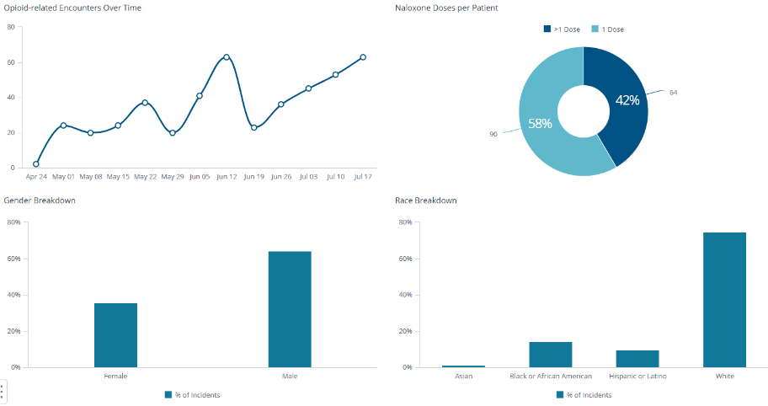

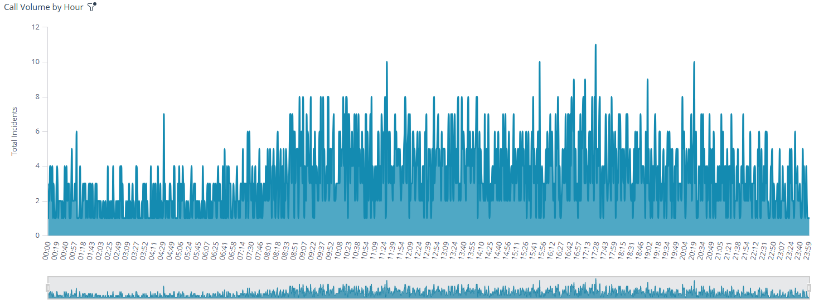
Project: 6.1-7312022REM Project Name: 6.1-July2022REM (Cancelled)
Funding Amount: $0 PO Amt: $0 Exp Amt: $0
Project Expenditure Category: 6.1 Government Services

Project Overview

Purchase of a portable Remote Public Safety Answering Point (PSAP) system that fully integrates with the VESTA 911 operations center. It enables EMS providers to answer 911 calls from remote locations. With COVID-19, quarantining, social distancing, and other mitigation procedures exposed understaffing of 911 operations.

Use of Evidence

The goal of this project is to increase public health and safety by reducing ambulance response times. This project does not use evidence-based interventions, accordingly, $0 are allocated for this purpose.

Performance Report: The output is the purchase and installation of the equipment. The reporting metric is the installation and integration of the equipment with the 911 operations center. Percentage of Completion: 0%. Purchase Order cancelled. Equipment not received at 6/30/2024. (Project cancelled and removed from SLFRF)

Community and Infrastructure Projects

Project: 6.1-7312022FHC Project Name: 6.1-July2022FHC (Study Homelessness)
Funding Amount: $90,000 PO Amt: $0 Exp Amt: $90,000
Project Expenditure Category: 6.1 Government Services
Project Overview
Manatee County commissioned the Florida Housing Coalition to prepare and present a study to better understand and utilize resources available to address the homeless population of the County. The outcome is completion of the study and reporting metric is percentage of completion and then evaluating and incorporating the results of the study as determined by county administration. Project is at 100% completion as of June 30, 2025.
Use of Evidence

The goal of this project is to evaluate the study to better utilize existing resources and to decrease homelessness in Manatee County. This project does not use evidence-based interventions, accordingly, $0 are allocated for this purpose.

Performance Report

Performance reporting metric is percentage of completion of the study. The project is at 100% completion as of June 30, 2024. The study is titled, “Manatee County’s Roadmap to Address Homelessness.” And is 50 pages long. The title page, table of contents and executive summary are included in this recovery report. The full report is available upon request.

Project: 6.1-01012023PSWR Project Name: 6.1-Jan2023PSWR (Parrish Sewer)
Funding Amount: $3,754,884 PO Amt: $3,548,335 Exp Amt: $451,665
Project Expenditure Category: 6.1 Government Services
Project Overview
Design and construct 3200 LF of 4-inch force main and 250 FT of gravity sewer in Parrish Village. Outside contractors will be used to complete all phases of the project. The project completion is at < 10% of the total funding amount as of June 30, 2025.

Use of Evidence

The goal of this project is to construct a new gravity sewer in Parrish. This project does not use evidence-based interventions, accordingly, $0 are allocated for this purpose.

Performance Report

Performance reporting metric is percentage of completion of the construction project. The project is at <10% completion as of June 30, 2024.

Project: 6.1-10012022SW55TH Project Name: 6.1-Oct2022SW55TH (SW Repair 55th St)
Funding Amount: $ 133,802 PO Amt: $0 Exp Amt: $133,802
Project Expenditure Category: 6.1 Government Services
Project Overview
Repair stormwater piping. Line approximately 1000' of corrugated metal pipe (18" - 30") using cured-in-place pipe (CIPP) lining.
Outside contractors will be used to complete all phases of the project. Purchase orders have been placed with the vendor. Performance reporting metric is percentage of completion of the construction project. The project completion is 100% of the total funding amount as of June 30, 2024.
Use of Evidence

The goal of this project is to repair/replace construct stormwater piping. This project does not use evidence-based interventions, accordingly, $0 are allocated for this purpose.

Performance Report

Purchase orders have been placed with the vendor. Performance reporting metric is percentage of completion of the construction project. The project completion is 100% of the total funding amount as of June 30, 2025.

Project: 6.1-10012022SW4TH Project Name: 6.1-Oct2022SW4TH (SW Repair 4th Ave.)
Funding Amount: $ 174,535 PO Amt: $0 Exp Amt: $174,535
Project Expenditure Category: 6.1 Government Services
Project Overview
Repair stormwater piping. Line approximately 900' of corrugated metal pipe (18" - 30") using cured-in-place pipe (CIPP) lining.
Outside contractors will be used to complete all phases of the project. Purchase orders have been placed with the vendor. Performance reporting metric is percentage of completion of the construction project. The project completion is 100% of the total funding amount as of June 30, 2024.
Use of Evidence

The goal of this project is to repair/replace construct stormwater piping. This project does not use evidence-based interventions, accordingly, $0 are allocated for this purpose.

Performance Report

Purchase orders have been placed with the vendor. Performance reporting metric is percentage of completion of the construction project. The project completion is 100% of the total funding amount as of June 30, 2025.

Project: 6.1-01012023SW9TH Project Name: 6.1-Jan2023SW9TH (SW Repair 9th St)
Funding Amount: $ 343,897 PO Amt: $0 Exp Amt: $343,897
Project Expenditure Category: 6.1 Government Services
Project Overview
Repair stormwater piping. Line approximately 550' of corrugated metal pipe (54") using cured-in-place pipe (CIPP) lining.
Outside contractors will be used to complete all phases of the project. Purchase orders have been placed with the vendor. Performance reporting metric is percentage of completion of the construction project. The project completion is 100% of the total funding amount as of June 30, 2024.
Use of Evidence

The goal of this project is to repair/replace construct stormwater piping. This project does not use evidence-based interventions, accordingly, $0 are allocated for this purpose.

Performance Report

Purchase orders have been placed with the vendor. Performance reporting metric is percentage of completion of the construction project. The project completion is 100% of the total funding amount as of June 30, 2025.

ADMINISTRATION
Project: 7.1-1231 Project Name: 7.1-March-December (Admin 2021)
Funding amount: $136,316 PO Amt: $0 Exp Amt: $136,316
Project Expenditure Category: 7.1-Administrative Expenses
Project Overview
Payroll for the administration of the SLFRF funds and outside consulting and assistance regarding applicable US Treasury rules and guidelines.

Use of Evidence
Not applicable for Administration of SLFRF funds.

Performance Report
Day-to-Day Administration of SLFRF funds. Consulting provided on an as needed basis.

Project: 7.1 – 33122 Project Name: 7.11 - January - March 2022
Funding amount: $20,966 PO Amt: $0 Exp Amt: $20,966
Project Expenditure Category: 7.1-Administrative Expenses
Project Overview
Payroll for the administration of the SLFRF funds.

Use of Evidence
Not applicable for Administration of SLFRF funds.

Performance Report
Day-to-Day Administration of SLFRF funds

Project: 7.1-6302022 Project Name: 7.1-April-June 2022
Funding amount: $26,716 PO Amt: $0 Exp Amt: $26,716
Project Expenditure Category: 7.1-Administrative Expenses

Project Overview
Payroll for the administration of the SLFRF funds.

Use of Evidence
Not applicable for Administration of SLFRF funds.

Performance Report
Day-to-Day Administration of SLFRF funds

Project: 7.1-7312022ADMIN Project Name: 7.1-July2022ADM
Funding amount: $51,207.97 PO Amt: $0 Exp Amt: $51,207.97
Project Expenditure Category: 7.1-Administrative Expenses

Project Overview
Payroll for the administration of the SLFRF funds.

Use of Evidence
Not applicable for Administration of SLFRF funds.

Performance Report
Day-to-Day Administration of SLFRF funds

Project: 7.1-10012022 Project Name: 7.1-Oct2022ADM
Funding amount: $27,506.70 PO Amt: $0 Exp Amt: $27,506.70
Project Expenditure Category: 7.1-Administrative Expenses
Project Overview
Payroll for the administration of the SLFRF funds.

Use of Evidence
Not applicable for Administration of SLFRF funds.

Performance Report
Day-to-Day Administration of SLFRF funds

Project: 7.1-01012023ADM Project Name: 7.1-Jan2023ADM
Funding amount: $28,086.14 PO Amt: $0 Exp Amt: $28,086.14
Project Expenditure Category: 7.1-Administrative Expenses
Project Overview
Payroll for the administration of the SLFRF funds.

Use of Evidence
Not applicable for Administration of SLFRF funds.

Performance Report
Day-to-Day Administration of SLFRF funds

Project: 7.1-04012023ADM Project Name: 7.1-Apr2023ADM
Funding amount: $32,398.31 PO Amt: $0 Exp Amt: $32,398.31
Project Expenditure Category: 7.1-Administrative Expenses
Project Overview
Payroll for the administration of the SLFRF funds.

Use of Evidence
Not applicable for Administration of SLFRF funds.

Performance Report
Day-to-Day Administration of SLFRF funds

Project: 7.1-07012023ADM Project Name: 7.1-July2023ADM
Funding amount: $34,682.66 PO Amt: $0 Exp Amt: $34,682.66
Project Expenditure Category: 7.1-Administrative Expenses
Project Overview
Payroll for the administration of the SLFRF funds.

Use of Evidence
Not applicable for Administration of SLFRF funds.

Performance Report
Day-to-Day Administration of SLFRF funds

Project: 7.1-10012023ADM Project Name: 7.1-Oct2023ADM
Funding amount: $27,676.48 PO Amt: $0 Exp Amt: $27,676.48
Project Expenditure Category: 7.1-Administrative Expenses
Project Overview
Payroll for the administration of the SLFRF funds.

Use of Evidence
Not applicable for Administration of SLFRF funds.

Performance Report
Day-to-Day Administration of SLFRF funds
Project: 7.1-01012024ADM Project Name: 7.1-Jan2024ADM
Funding amount: $24,748.55 PO Amt: $0 Exp Amt: $24,748.55
Project Expenditure Category: 7.1-Administrative Expenses
Project Overview
Payroll for the administration of the SLFRF funds.

Use of Evidence
Not applicable for Administration of SLFRF funds.

Performance Report
Day-to-Day Administration of SLFRF funds

Project: 7.1-04012024ADM Project Name: 7.1-Apr2024ADM
Funding amount: $16,986.09 PO Amt: $0 Exp Amt: $16,986.09
Project Expenditure Category: 7.1-Administrative Expenses
Project Overview
Payroll for the administration of the SLFRF funds.

Use of Evidence
Not applicable for Administration of SLFRF funds.

Performance Report
Day-to-Day Administration of SLFRF funds

Project: 7.1-7312022EY Project Name: 7.1-July2022EY
Funding amount: $39,995.50 PO Amt: $0 Exp Amt: $39,995.50
Project Expenditure Category: 7.1-Administrative Expenses
Project Overview
Consulting for the administration of the SLFRF funds.

Use of Evidence
Not applicable for administration of SLFRF funds.

Performance Report
Consulting to assist in the day-to-day administration of SLFRF funds.

Project: 7.1-10012022EY Project Name: 7.1-Oct2022EY
Funding amount: $6805.00 PO Amt: $0 Exp Amt: $6805
Project Expenditure Category: 7.1-Administrative Expenses
Project Overview
Consulting for the administration of the SLFRF funds.

Use of Evidence
Not applicable for administration of SLFRF funds.

Performance Report
Consulting to assist in the day-to-day administration of SLFRF funds.

Project: 7.1-01012023EY Project Name: 7.1-Jan2023EY
Funding amount: $4,277.50 PO Amt: $0 Exp Amt: $4,277.50
Project Expenditure Category: 7.1-Administrative Expenses
Project Overview
Consulting for the administration of the SLFRF funds.

Use of Evidence
Not applicable for administration of SLFRF funds.

Performance Report
Consulting to assist in the day-to-day administration of SLFRF funds.

Project: 7.1-04012023EY Project Name: 7.1-Apr2023EY
Funding amount: $17,215.50 PO Amt: $0 Exp Amt: $17,215.50
Project Expenditure Category: 7.1-Administrative Expenses
Project Overview
Consulting for the administration of the SLFRF funds.

Use of Evidence
Not applicable for administration of SLFRF funds.

Performance Report
Consulting to assist in the day-to-day administration of SLFRF funds.
Project: 7.1-01012024EY Project Name: 7.1-Jan2024EY
Funding amount: $172,104.50 PO Amt: $172,104.50 Exp Amt: $0
Project Expenditure Category: 7.1-Administrative Expenses
Project Overview
Consulting for the administration of the SLFRF funds, including compliance review.

Use of Evidence
Not applicable for administration of SLFRF funds.

Performance Report
Consulting to assist in the day-to-day administration of SLFRF funds, including compliance review.

GOVERNMENT SERVICES-PAYROLL
Project: 6.1-09302023PR Project Name: 6.1-SEPT2023PR
Funding amount: $52,599,108 PO Amt: $0 Exp Amt: $52,599,108
Project Expenditure Category: 6.1-Revenue Replacement
Project Overview
Reimbursement of eligible payroll expenses for essential county employees, a traditional government service provided by Manatee County Government.

Use of Evidence
Not applicable for expense reimbursement.

Performance Report
Reporting metric is the completion of the payroll reimbursement. 100% complete.

GOVERNMENT SERVICES-PAYROLL
Project: 6.1-09302023PR Project Name: 6.1-SEPT2023PR
Funding amount: $52,599,108 PO Amt: $0 Exp Amt: $52,599,108
Project Expenditure Category: 6.1-Revenue Replacement
Project Overview
Reimbursement of eligible payroll expenses for essential county employees, a traditional government service provided by Manatee County Government.

Use of Evidence
Not applicable for expense reimbursement.

Performance Report
Reporting metric is the completion of the payroll reimbursement. 100% complete
Project: 6.1-07012024PR Project Name: 6.1-JULY2025PR
Funding amount: $11,609,099 PO Amt: $0 Exp Amt: $11,609,099
Project Expenditure Category: 6.1-Revenue Replacement
Project Overview
Reimbursement of eligible payroll expenses for essential county employees, a traditional government service provided by Manatee County Government.

Use of Evidence
Not applicable for expense reimbursement.

Performance Report
Reporting metric is the completion of the payroll reimbursement. 100% complete
Project: 6.1-10012024PR Project Name: 6.1-OCT2024PR
Funding amount: $245,117 PO Amt: $0 Exp Amt: $245,117
Project Expenditure Category: 6.1-Revenue Replacement
Project Overview
Reimbursement of eligible payroll expenses for essential county employees, a traditional government service provided by Manatee County Government.

Use of Evidence
Not applicable for expense reimbursement.

Performance Report
Reporting metric is the completion of the payroll reimbursement. 100% complete

