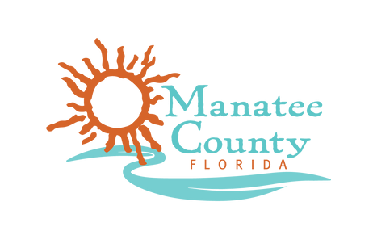

GOVERNMENT EFFICIENCY LIAISON COMMITTEE (GELC)
MANATEE COUNTY ADMINISTRATION BUILDING 5TH FLOOR, Manatee ROOM
1112 MANATEE AVENUE W, BRADENTON, FL 34205

AGENDA
TUESDAY, SEPTEMBER 23RD 2025 – 2:00 PM

- CALL TO ORDER
  - Invocation
  - Pledge of Allegiance
- POTENTIAL NOVEMBER MEETING DATE AND TIME
  - November 7th, 2025 10:00 AM - 11:30 AM
  - November 10th, 2025 10:00 AM - 11:30 AM
  - November 17th, 2025 10:00 AM - 11:30 AM
- DISCUSSION ON LIMITING CITIZEN COMMENTS TO 3 MIN
- ORGANIZTIONAL CHARTS BY DEPARTMENT
- LAKEWOOD RANCH BASEBALL FIELD
- BREAKDOWN OF RESERVES
- COMPARISON OF COUNTIES AROUND THE SIZE OF MANATEE COUNTY
- PRESENTATION – GELC DISCUSSION GUIDE
- DISCUSSION – AREAS OF INTEREST
- CITIZEN COMMENTS
- MEMBER COMMENTS
- ADJOURNMENT

