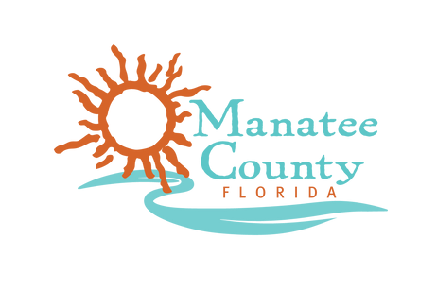

GOVERNMENT EFFICIENCY LIAISON COMMITTEE (GELC)
MANATEE COUNTY ADMINISTRATION BUILDING 5TH FLOOR, MANATEE ROOM
1112 MANATEE AVENUE W, BRADENTON, FL 34205

AGENDA
TUESDAY, APRIL 14TH 2026 – 10:00 AM

- CALL TO ORDER
  - Invocation
  - Pledge of Allegiance
  - Approval of Minutes 3/17/2026
  - Next Meeting Date 5/26/2026 10:00 AM
- LETTER TO FLORIDA CFO WAS DROPPED OFF ON 1/21/2026
  - Still waiting on a response
- DISCUSSION WITH INTERIM CFO – CLAUDIA CAMPOS
- SELECTION OF FINAL MEETING DATES – CROSLEY
- FINAL REPORT TEMPLATE – BRENT
- PRESENTATION ON ILA SPREADSHEET – CROSLEY
- NO SUBMMITTED CITIZEN COMMENTS
- CITIZEN COMMENTS
- MEMBER’S COMMENTS
- ADJOURNMENT

